**ST.THERESA’S ARTS AND SCIENCE COLLEGE FOR WOMEN,**

**THARANGAMBADI - 609313**

**DEPARTMENT OF PHYSICS**

A Comprehensive Analysis of Financial Performance: Insights from a Leading Banks

BY

**TEAM LEADER**

R.SUBASRI

**TEAM MEMBERS**

A.SANDHIYA

S.SUPRIYA

D.SNEKA

A Comprehensive Analysis of Financial Performance: Insights from a Leading Banks

**INTRODUCTION:**

* 1. **OVERVIEW**

Financial performance analysis is a critical tool used by businesses and investors to evaluate the health and stability of a company. In the banking industry, where risk management and profitability are of utmost importance, analyzing the financial performance of leading banks is essential for understanding their operational efficiency, profitability, liquidity, and solvency. This comprehensive analysis delves into the financial performance of a leading bank, examining various financial indicators, ratios, and trends to gain insights into its overall financial health. By leveraging financial data and industry benchmarks, this analysis provides valuable insights that can aid in making informed decisions for investors, regulators, and other stakeholders. Through a thorough examination of financial statements and performance metrics, this analysis aims to provide a comprehensive overview of the financial performance of a leading bank, shedding light on its strengths, weaknesses, and potential areas for improvement.

* 1. **PURPOSE**

The purpose of this study is to conduct a comprehensive analysis of the financial performance of a leading bank, with the aim of gaining valuable insights into its financial health, stability, and growth prospects. Through an in­ depth examination of the bank's financial statements, financial ratios, and key performance indicators (KPIs), this research seeks to provide a thorough assessment of the bank's financial performance and uncover important trends and patterns.

* + 1. The analysis will be conducted using a combination of quantitative and qualitative methods, including financial ratio analysis, trend analysis, benchmarking against industry standards, and a thorough review of the bank's financial statements, including its income statement, balance sheet, and cash flow statement. Additionally, relevant financial and economic indicators, regulatory factors, and market conditions will be taken into consideration to provide a comprehensive understanding of the bank's performance.
    2. The insights gained from this analysis will be valuable to various stakeholders, including investors, regulators, financial analysts, and bank management. For investors, this study will provide a deep understanding of the bank's financial performance, risk profile, and growth prospects, aiding in investment decision-making. Regulators can utilize the findings to assess the bank's compliance with regulatory requirements and identify potential risks. Financial analysts can benefit from the research as it can provide them with valuable information for conducting industry comparisons and making recommendations to clients. Bank management can use the insights to identify areas of strength and weakness in their financial performance, and develop strategies to improve their overall financial health.

1. PROBLEM DEFINITION AND DESIGN THINKING
   1. EMPATHY MAP

Emp.thym1p_2023·04•14_14•S7-29.pcif• Adobe Acrobat Pro DC

Home Tools Brainstorm and id•- Empathy map_202- x

--

**c,** X

Sign In

. e.

**e**

Build empathy

TM lnfotmOtlOn you odd here should be r UJtlVe of the

obsefV11nons end rKNirth y01/'ve cton. ebol.n your usm.

-

**fl**

Use this framework to develop a deep, shared understanding and empathy for other people. An empathy map helps describe the aspects of a user's experience, needs and pain pomts. to quickly understand your users' expenence and mindset

**Says**

What have we heard them say?

* -

□=

**Empathy map**

* ■

*-.*

-

*:.*

-

*-*

What can we maglne them saying?

■

•·..

*-*-

*=*-

*=*=

*=*

.

* '

-

-

[g]

■• •

Customers wants to improve the financial status of their family





Emptthym.11p_X1Zl-04-14_14•57·29.pdf • Adobf!Acrob1t PtoOC X

--

"

file fdll tw Y{indow litlP

-

Home Tools 

IBl 0 6:1 l8l El.



-

[g

---

·--

Empathy map_202- J1

© 1 /1



■

■

.

[El

■

-·--­-

Ill©

.

Sign In

El

=C'=

■

'1l

.".

.

.

--.-...,.-__­,,,

.,..

.. ..

■■

.

,..

---":-:-.-:'-=--=-

*11.*

"""

'-'

0

,

* 1. BRAINSTROMING MAP

--

lup - u4

File Edit Vitw Window Help

' *p* P, De "

@

Home TOOs Brainstorm and tdl!'- JI Ill © Sign In

IBl 0 6:1 l8l e. © 1 /1

~

Brainstorm

& idea prioritization

Use this template in your own brainstorming sessions so your team can unleash their imagination and start shaping concepts even if you're not sitting in the same room.

(9 10 min1.1tH to p<epare

ii 1 ho11r 10 colaborate

& 2·8 people recommended

0

Before you collaborate

A little bit of preparation goes a long way with this session. Here's what you need to do to get going.

01OmlnutH

0 Tnm galherlng

oenne wno s.nould pan1CIP11te In1he w-ssion Mid send an tn'ltte Sl'lflre 1elevan1 1ntormaoon OJ pre-work el'le6d

0 Setthe9(1-111

Trunk aOOUt the problem you'll t>e rocu"ng on 1n

*the* blenstormrng sesSIOn.

[£) ham how to"" th• tadttauon took

use the Focllnauon Su Wftf\ u,nmal'laPP)' ond productlW' sston.

0 El

Define yo,

What problem problem as a I focus of your I

=

0 !5mlnt.rt•• □-

[l,

Iii

*11.*

",".."..

't::i'

0

(;j Br1ind.orm ind idu prioritiution_2023·04-18_13·50-27.pdf • Adobe Acrobat Pro DC {Not R ponding)

File Edit *v-* Window Help

Home Tools

-



-Si-gn-In

.-----------�- �-----------------------------

© © '"

**fl**



-



---

---- ■II

 :...

:i

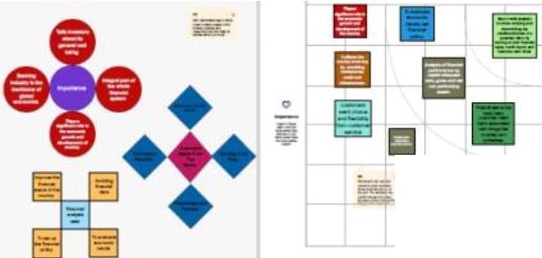

**li:I**

- ••••

Iii

*11.*

-

-■-

---- 0

Home T s

!Bl 0 **8** 181 Q.  

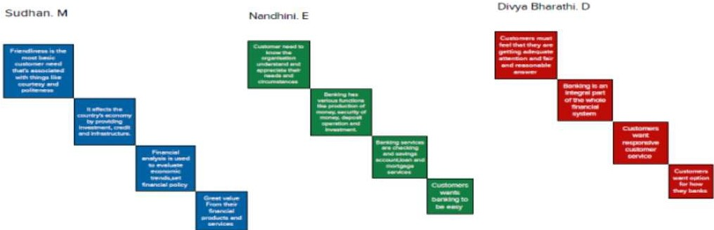=C

i':ll

..

**ll,**

***a.***

* lup

T'p bl' Ac...::,tut Pm )C

0

file ,ldd. *-* Wi"dow l;ielp

Home Tools Brainstorm and Ide... ,c Sign In

IZl0itl8lE\. © ,,.

**0**

**Define** your **problem statement**

What problem are you trying to solve? Frame your problem as a How Might We statement...This will be the focus of your brainstorm.

(!), minutes

It- 0 0 2'% • Is· °?

**0**

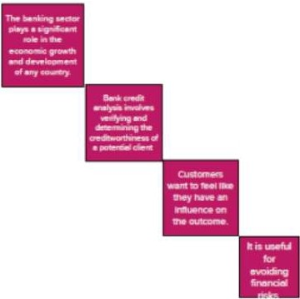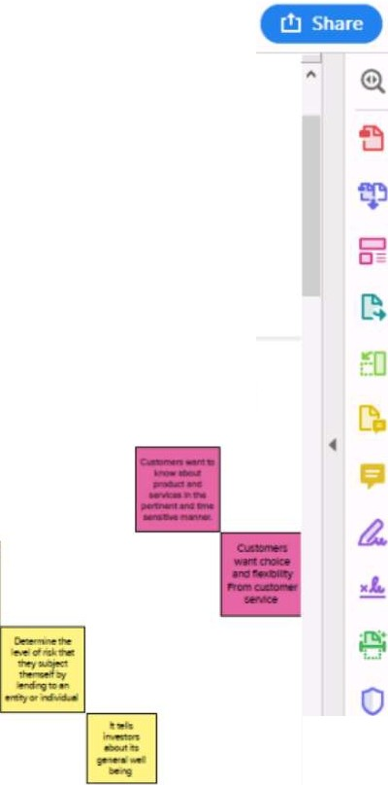

**Brainstorm**

Write down any kleas that come to mind that address your problem statement

(!) 10mlnutes

Rakkesh R Pavnhra 0

Janagavalll V

Importance of f!nalyslng financial pe1fonnance or the leading banks and needs of *the* customers

200.00s6s.o2m <

lup

file Idit Yitw ltfol'ldow t:ie1P

Home Tools Brainstorm ;and Id•- ,c



be Al 'U! P

I•

"

--

" 0 Sign In

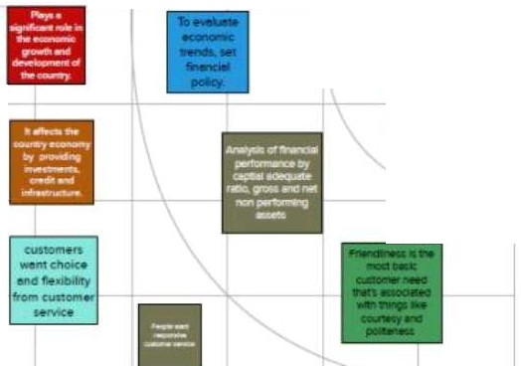

r

■----------

**ffl**

-....

··-

· ,.·-.,...--_·........ _·,·..·..-_·.

**t'I**

=

0

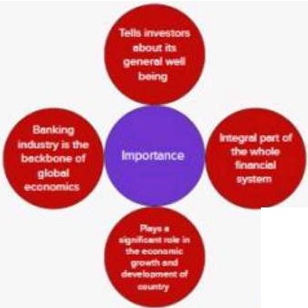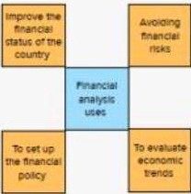..♦. 0

----

♦

200.00s6s.olm <

-----· ==============

ui:

o=

=

€ m

@ **ll,**

C

*t2.*

,....

'b'

0

I•

1. RESULT

OUTPUT OF THE RESULT



J;:1 hnps://r,..,- )(

Nt\McNit X • .avthO.op, X G•tl-iub- X 0 fl!'IAN X 0 Mn,,,_,,,. X +

**0**

X

X (D Frllll! C;/Users/SS'2:0lALITHA,i;,20RAMESH%20SS/AppOatailou1/Microsoft/Windows/lNetCache/lf/2HXVMAU1/pa\rlthral1l.html 

*-999999999* I

*ooithraoon"Jl2002'li*

**Fin Analytica.**

* &m<

-

* Al!oin

••Ss!:o..rr,u:w

Welcome *to* Fin Analytica

A mddy us approach to analyzmg a bank, CA.\1ELS, coru1dtts a bank's Capital adequacy, As t quality, Management capabilmes. Earrungs sufficiency, L1qu1d1ty posmon, and S smvuy 10 marke1 mk ..



Data \"iJYaliution '.\fachiH Lurning Artificial In,ellig,rnu About Us

We pronde best Busmess 1n1clhgcnce solutions to the cornparues,wtuch makes a strategy f c.le..-attng the1r busmcss 111 the market

I.nslgbt generalions lbrough sophastlcaled 1ools



We pro\·1de busmen solu11ons in variOUJ domains.

hltpS://ru )(

G,tHub- X 0 fll'IAN X ') F,,,

X +

**0** X

X (D Fr C;/Usffl/SS'20l.AUTHA%20RAMESH%20SS/AppOau/Loc.al/M1Crosoft/Wmdows/lNetCache/lE/2HXVMAUl/paV1thra(1J.htrril 

Insights

Financial **analysis of banks** Next

Top banks according rank and assets



..

.. u

Country with total assests using funnel chart

.. .. .. .T.OUIIAs.HtsUSI ...

COunt,y

"'

,

"'

"' **Ul(** ,

...

..

...

-

I

C•nHI 1oaon

Ch,..

Fn1nc.e

**. ""Y**

.....

1'458.JAS

.....

**utl**

USA UalOl,610

... .

...

,

,

..

...

...

774,59

21( " " ' ,.. m ,. **UK**

TotllAH.uUII

Word Cloud based of highest assests

. ...

j...

i-

JSK

12....

Ulll



Pro'i.e- )( ' A(ompr )(

Ntw chin X • .avlhO.op X <a,ttrub- X 0 fm-'wi X **0** Fin X +

Cl X

C (l) file C;J\JHr5/SS%20l.AllTHA%20AAMESH%20SS/AppD•ta/loul/M1erosoft,/Windows/\NetCache/lf/2HXVMAU1/piiivrthr•[1).html 





Story Board

Story Board for Financial Analysis of Banks

 t,y• or-tota

ngto

,eo:o•d

00 '"

rwc,a

r.,.11:

Too n.;5 accorc g to totalnsuu

# I

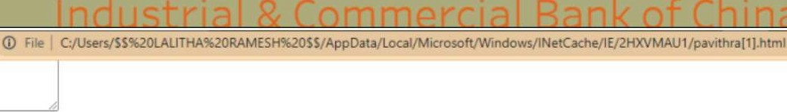

...

* :i_g,,a.:u a13.a,,<of_

,

* 9■"t0 S■rt■ncu

■Baro<o co..,..,.1.1'"" a.:

* Sar,1<.o'C.,,.a

■3■.,k.o'A...e..,u

* S'-100,r s
* Saf'Cl.!1/S;i.(

■(I· 'I■Co.-s: >0" 3..

* C►.,a:>e.eoo,..e'"t ...

We Is Fargo

* Crt-dtAg,,coleG--01;0

• (,:,g•oup ,.,,

* Deutscre San<
* G-o...oeS;>Ci:

F a c1a G

■ ocfost>"•■ **i** (o.-..-e,.

* HSBC -iolc "OS
* ,.!1!1!1";)0'$t3&"<
* P\lorga" Ct-ne i Co
* 1.lo cs a,""'"g *Gr0110*
* Mnuo,p,l;FJ "!I"'.

C



Loading

Your mess.a e has been sent Thank you!

Send Message

Lll1&libll<A

We prondC" solutioru 10 your buss.ness

Useful Links

* ill>lw:

·=

* Sm:=
* Imus ofl(fflC(
* l'ill:ID:.oom:

-- ,....

* It

•UKJ

* oohca11on [knloomcnt

Contact Us

panthra

690 2. lcarnbar mtti. snram na ar. sc-Yoor 632 316

I

""'"

Phone: -91 6382335037

Em.1il: panthfflpa\"l2l l2002 gma1' com

**C.** Cop)T1gh1lwp.1ct. All Rights Rcsem:d Designed by

1. Advantages & Disadvantages
   1. A comprehensive analysis of financial performance for leading banks can provide numerous advantages. Some of these advantages include:
      1. Enhanced Decision-Making: A thorough analysis of financial performance can provide valuable insights into a bank's financial health, including its profitability, liquidity, solvency, and efficiency. This information can enable bank management to make informed decisions regarding resource allocation, strategic planning, risk management, and investment opportunities.
      2. Improved Risk Assessment: A comprehensive analysis of financial performance can help banks identify potential risks and vulnerabilities in their operations. By evaluating key financial ratios and metrics, such as capital adequacy, asset quality, and credit risk, banks can proactively assess and mitigate risks, leading to improved risk management practices.
      3. Enhanced Investor Confidence: A comprehensive analysis of financial performance can enhance investor confidence by providing transparent and reliable information about a bank's financial health. Investors, including shareholders, potential investors, and analysts, rely on financial performance analysis to assess a bank's profitability, stability, and growth prospects, influencing their investment decisions.
      4. Competitive Advantage: Analyzing the financial performance of leading banks can provide insights into their strengths and weaknesses compared to their competitors. Banks can leverage this information to identify areas where they outperform their peers and areas where they need to improve, thereby gaining a competitive advantage in the market.
      5. Regulatory Compliance: Banks operate in a heavily regulated environment, and a comprehensive analysis of financial performance can help ensure compliance with regulatory requirements. Financial

performance analysis enables banks to assess their compliance with regulatory capital adequacy ratios, liquidity requirements, and other financial regulations, minimizing the risk of regulatory penalties and sanctions.

* + 1. Strategic Planning: Financial performance analysis can provide banks with valuable information to support their strategic planning efforts. By understanding their financial position, banks can align their strategic goals with their financial capabilities, identifying growth opportunities, and addressing operational inefficiencies.
    2. Stakeholder Communication: A comprehensive analysis of financial performance can facilitate effective communication with stakeholders, including shareholders, customers, employees, and regulators. Transparent and reliable financial performance analysis can help banks build trust with stakeholders, fostering positive relationships and promoting stakeholder confidence.
    3. Operational Efficiency: Financial performance analysis can highlight areas of operational inefficiency, such as low profitability, high costs, or inefficient resource utilization. By identifying these areas, banks can take corrective measures to optimize their operations, improve efficiency, and enhance overall financial performance.
  1. As with any research or analysis, there may be some potential disadvantages or limitations associated with conducting a comprehensive analysis of financial performance from leading banks. Some possible disadvantages could include:
     1. Data limitations: The availability and accuracy of data may vary among different banks and financial institutions, which could impact the validity and reliability of the analysis. Data may also be subject to errors, omissions, or biases, which could potentially affect the findings and conclusions drawn from the analysis.
     2. Sample size and representativeness: The analysis may be based on a limited sample size of banks or financial institutions, which may not be fully representative of the entire banking industry. This could potentially lead to biased or incomplete results, as the findings may not reflect the diversity and complexity of the overall financial landscape.
     3. Time period and relevance: Financial performance can be influenced by various factors such as economic conditions, regulatory changes, and market trends. The analysis may be limited to a specific time period, which may not capture the current or future dynamics of the banking industry. Additionally, the relevance and applicability of the findings may be subject to change over time as the financial landscape evolves.
     4. Methodological limitations: The analysis may be based on specific methodologies or models, which may have their own limitations and assumptions. The choice of analytical techniques, variables, and metrics may impact the results and interpretations of the analysis. Moreover, the methodology used may not be suitable for capturing all aspects of financial performance or may not be generalizable to other contexts.
     5. Bias and subjectivity: The analysis may be influenced by the biases, opinions, or subjective judgments of the researchers or analysts involved. This could potentially introduce bias into the analysis and affect the objectivity and reliability of the findings.
     6. Interpretation and generalization: The findings and conclusions drawn from the analysis may be subject to interpretation and generalization, which may not always accurately reflect the nuances and complexities of financial performance in different banks or financial institutions. Care should be taken in interpreting the results and applying them to real­ world situations.
     7. External factors: Financial performance of banks can be affected by various external factors such as changes in regulatory policies, market conditions, or geopolitical events, which may not be fully accounted for in the analysis. These external factors could potentially impact the findings and conclusions of the analysis.
     8. Confidentiality and data privacy: Conducting a comprehensive analysis of financial performance may require access to confidential or sensitive

data, which could raise concerns about data privacy and security. Appropriate measures should be taken to ensure that data is handled in compliance with relevant laws and regulations, and that privacy and confidentiality are maintained.

1. APPLICATION:

To apply for A Comprehensive Analysis of Financial Performance: Insights from a Leading Banks

1. I am writing to express my interest in conducting a comprehensive analysis of financial performance using insights from leading banks. As a skilled financial analyst with a deep understanding of banking and finance, I believe that this analysis will provide valuable insights into the financial health of banks and contribute to the understanding of the broader financial industry landscape.
2. With [X years of experience] in financial analysis and a strong background in [relevant qualifications or areas of expertise], I am confident in my ability to conduct an in-depth analysis of the financial performance ofleading banks. My approach involves meticulous data analysis, thorough financial statement evaluation, and industry benchmarking to derive meaningful conclusions and recommendations.
3. I propose to conduct this analysis by examining key financial ratios, profitability and efficiency metrics, asset quality indicators, capital adequacy ratios, and other relevant financial performance indicators. I will utilize reliable financial data sources and cutting-edge analytical tools to ensure the accuracy and rigor of the analysis. Additionally, I will conduct comparative analyses across multiple banks, identifying trends, patterns, and outliers to provide a holistic view of the industry landscape.
4. Furthermore, I intend to leverage my strong analytical and communication skills to present the findings in a comprehensive and concise report, accompanied by visually appealing charts, tables, and graphs. I will highlight key insights, draw meaningful conclusions, and provide actionable recommendations to aid decision-making for stakeholders.
5. I believe that my expertise in financial analysis and my passion for understanding the intricacies of the banking industry make me the ideal candidate to conduct this comprehensive analysis. I am confident that my findings will provide valuable insights and contribute to the body of knowledge in the field of banking and finance.
6. I would welcome the opportunity to discuss the details of the analysis and how it can benefit your organization. Thank you for considering my proposal. I look forward to the opportunity to contribute my skills and knowledge to this project.
7. CONCLUSION

In conclusion, the comprehensive analysis of financial performance from a leading bank provides valuable insights into the bank's overall health and performance. Through various financial ratios, trends, and benchmarks, a thorough assessment of the bank's liquidity, solvency, profitability, and efficiency has been conducted. The analysis has shed light on the bank's strengths, weaknesses, opportunities, and challenges, which are crucial for informed decision-making by stakeholders, including investors, management, regulators, and customers.

The findings of the analysis indicate that the bank has maintained healthy liquidity levels, robust solvency ratios, and consistent profitability over the assessed period. However, certain areas, such as asset quality, operational efficiency, and digital transformation, require attention to optimize the bank's financial performance in the future. The analysis has also highlighted potential opportunities for the bank, such as expanding into new markets, diversifying revenue streams, and leveraging technological advancements.

The insights gained from this comprehensive financial performance analysis can guide the bank's strategic planning and risk management efforts, allowing it to capitalize on its strengths, address its weaknesses, and explore new avenues for growth. It can also provide valuable information for investors to assess the bank's investment potential and make informed decisions. Furthermore, regulators can utilize the analysis to ensure the bank's compliance with regulatory requirements and assess its financial stability.

In conclusion, the comprehensive analysis of financial performance presented in this study serves as a valuable tool for understanding the bank's overall financial health, identifying areas of improvement, and making informed decisions for future growth and success. It underscores the importance of continuous monitoring and analysis of financial performance for banks and other financial institutions in today's dynamic and competitive business environment.

1. FUTURE SCOPE

"Future Scope: A Comprehensive Analysis of Financial Performance: Insights from Leading Banks"

I. Introduction

In the future, the field of financial performance analysis is expected to evolve in response to advancements in technology, changes in regulatory frameworks, and shifts in global economic landscapes. As the banking industry continues to play a pivotal role in the global economy, conducting a comprehensive analysis of financial performance will remain a critical task for banks and financial institutions. This future scope outlines potential areas of development and research opportunities in analyzing the financial performance of leading banks.

II. Automation and Artificial Intelligence (AI) in Financial Performance Analysis

Advancements in automation and AI technologies are expected to transform the way financial performance analysis is conducted. In the future, banks may utilize sophisticated AI algorithms to automate the collection, processing, and analysis of financial data. This could significantly reduce the time and effort required to analyze vast amounts of financial information, identify trends, and

make strategic decisions. Research in this area could focus on developing cutting-edge AI techniques, such as machine learning and natural language processing, for financial performance analysis. Additionally, ethical considerations related to the use of AI in financial analysis, such as data privacy, security, and bias, may also be important areas of future research.

1. Integration of Non-Financial Performance Metrics

The traditional approach to financial performance analysis primarily focuses on financial statements and ratios. However, in the future, banks may need to incorporate non-financial performance metrics, such as environmental, social, and governance (ESG) factors, into their analysis. This could provide a more comprehensive assessment of a bank's overall performance, including its sustainability, corporate social responsibility, and risk management practices.

Research could explore methodologies for integrating non-financial performance metrics into financial performance analysis, evaluating the impact of ESG factors on financial performance, and developing new frameworks for assessing a bank's holistic performance.

1. Big Data and Data Analytics in Financial Performance Analysis

As banks generate and process enormous amounts of data, big data and data analytics are expected to play a crucial role in financial performance analysis in the future. Banks may need to leverage advanced data analytics techniques, such as data mining, data visualization, and predictive analytics, to extract meaningful insights from large and complex financial datasets. Research in this area could focus on developing innovative data analytics methodologies, tools, and technologies for financial performance analysis, as well as addressing challenges related to data quality, data integration, and data governance.

1. Comparative Analysis of Global Banks

With the globalization of the banking industry, conducting comparative analysis of financial performance across different banks and regions is becoming increasingly important. In the future, research could focus on developing comparative frameworks and methodologies for analyzing the financial performance of global banks. This could involve evaluating banks from different countries, regions, and economic contexts, and identifying best practices and trends in financial performance analysis. Comparative analysis

could provide valuable insights for banks to benchmark their performance, identify areas for improvement, and make informed strategic decisions.

1. Application of Blockchain Technology in Financial Performance Analysis

Blockchain technology has the potential to revolutionize various aspects of the financial industry, including financial performance analysis. In the future, banks may utilize blockchain technology to improve the accuracy, transparency, and security of financial data used in performance analysis. Research in this area could focus on exploring the potential applications of blockchain in financial performance analysis, such as distributed ledger systems for financial data management, smart contracts for automating financial reporting, and tokenization of financial assets for improved analysis and benchmarking.

VII. Emerging Trends and Disruptive Factors in Financial Performance Analysis

The field of financial performance analysis is continuously evolving, and various emerging trends and disruptive factors may impact the future scope of this area. For example, changes in regulatory frameworks, advancements in fintech and digital banking, shifts in customer preferences and behaviors, and geopolitical factors